Verticals
- Access [Deals with security related stuffs like login, 2FA, captcha and updating personal information]
- Security Implementation
- On-boarding and KYC
- Subscriptions

- Payments –

- Saas

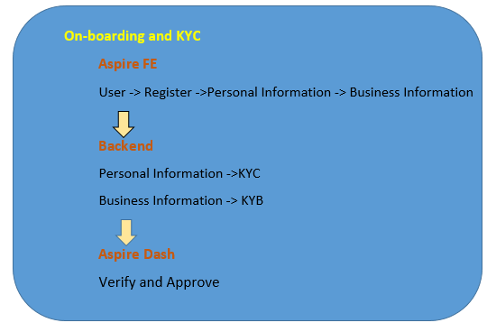

Payments Vertical
Provide Currency Debit account for Business
Allow User make transfer multiple current to multiple country in the world
Work Flows
- Accounts and Transaction Flow
- Local transaction
- Swift transaction
- Scheduled Transaction Flow
- Maker Checker Flow
- Dev Tools Flow

Accounts and Transaction Flow
- Local Transaction
- Login to Customer Front-End
- Click on Accounts Tab on LHN bar
- Choose the required account [SGD, IDR, USD, Etc.]
- Click on make a Transfer
[ Local – Local Exchange ]
- Select the Recipient
- Enter the Amount and click on Next button
- Verify the details in Transfer Review Page and Click on Continue
- Enter OTP as 1234
- Transfer Should be initiated.
- Click on Transactions Tab in LHN bar.
- Transaction should be visible in the past Transactions tab.
- Select Past Transactions and Click on latest transaction
- Admin can able to see 2 status – Initiated and Completed.
- Admin can Attach the Receipt
- Download the Details of the Transaction in pdf format.

- Swift Transaction
- Login to Customer Front-End
- Click on Accounts Tab on LHN bar
- Choose the required account [SGD, IDR, USD, Etc.]
- Click on make a Transfer
*[ Swift – Foreign Exchange ]
- Select the Recipient
- Enter the Amount and click on Next button
- Verify the details in Transfer Review Page and Click on Continue
- Enter OTP as 1234
- Transfer Should be initiated.
- Click on Transactions Tab in LHN bar.
- Transaction should be visible in the past Transactions tab.
- Select Past Transactions and Click on latest transaction
- Admin can able to see 3 status – Initiated, Completed and Completed.
- Admin can Attach the Receipt
- Download the Details of the Transaction in pdf format.
*Additional Fees will be applied

Scheduled Transaction Flow
- Login to Customer Front-End
- Click on Accounts Tab on LHN bar
- Choose the required account [SGD, IDR, USD, Etc.]
- Click on make a Transfer
- Select the Recipient
- Enter the Amount
- Click on Schedule Transfer
- Choose the Transfer date and Transfer Frequency [Weekly or Monthly] * Recurring
- Click on Continue
- Click on next and verify the details in Review transfer page.
- Click on Continue
- Verify that Recurring Transfer should be displayed.
- Click on Transaction on LHN bar
- Transaction should be visible in the Upcoming Tab.
- Admin can able to see 2 status – Initiated and Completed.
- Admin can Attach the Receipt
- Download the Details of the Transaction in pdf format.
Note: Admin can able to stop Manage Transfer by Modify / Stop Transfer.

Maker - Checker Flow
- Login to Customer Front-End as Maker (Finance Submit only)
- Click on Accounts Tab on LHN bar
- Choose the required account [SGD, IDR, USD, Etc.]
- Click on submit a Transfer
[ Local – Local Exchange
Swift – Foreign Exchange ]
- Select the Recipient
- Enter the Amount and click on Next button
- Verify the details in Transfer Review Page and Click on Continue
- Enter OTP as 1234
- Transfer Should be submitted.
- Click on transactions Tab and transfer should be available in Pending tab
- Submitter can able to see 2 status – transfer submitted , pending approval.
Note: Submitter can able to Modify and delete the transaction as well before approval
- Logout as Maker (Finance Submit only).
- Login to as Checker (Finance Transfer only).
- Click on Transactions on the LHN Tab
- Click on Pending Tab.
- Checker can able to see Approve and More –[Reject / Modify transfer]
- Checker can able to approve the Transfer
- It will show as Transfer Initiated.t
- Now the transaction will be moved to past Tab.

Dev Tools Flow
- Login to dash.
- Settings -> Dev Tools -> Genie -> Scenario Builder
- Select an Scenario / Create a Scenario
- Click on eye icon.
- Select the country, Business Type,
- Click on Debit Accounts and choose the Required account to be generated
- Set/Add the Balance to the and click on Make a Wish.
- Test account will be generated .
- Copy the email id of Director
- Login with CF.

- Login Page
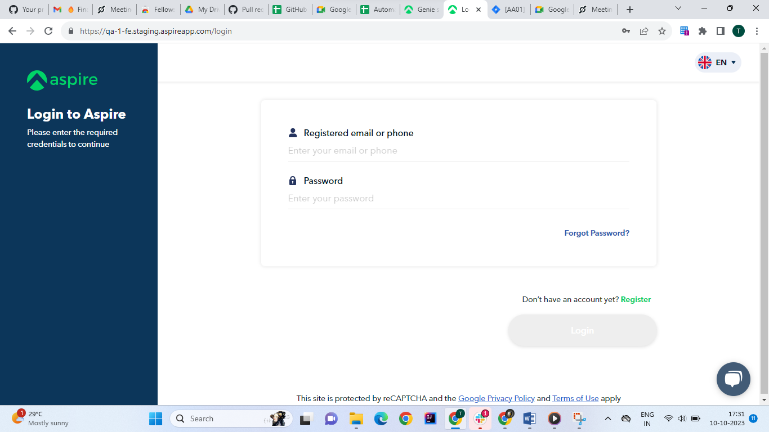

- Home Page
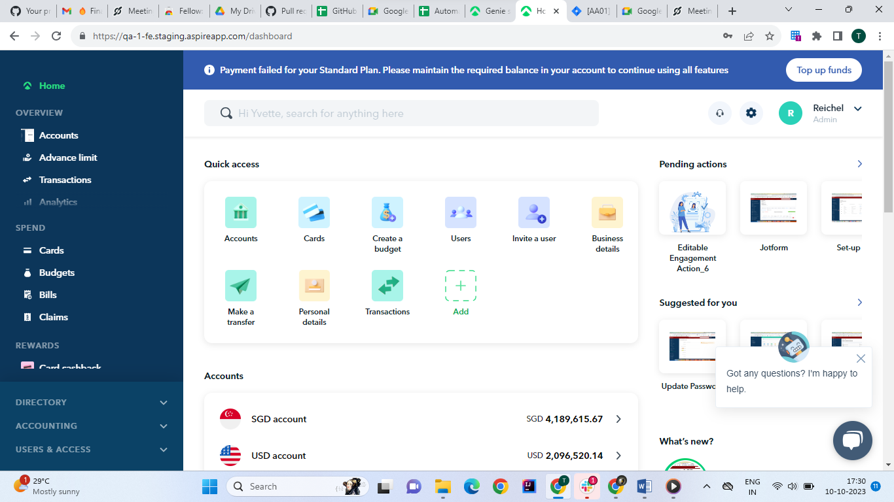

Accounts Page
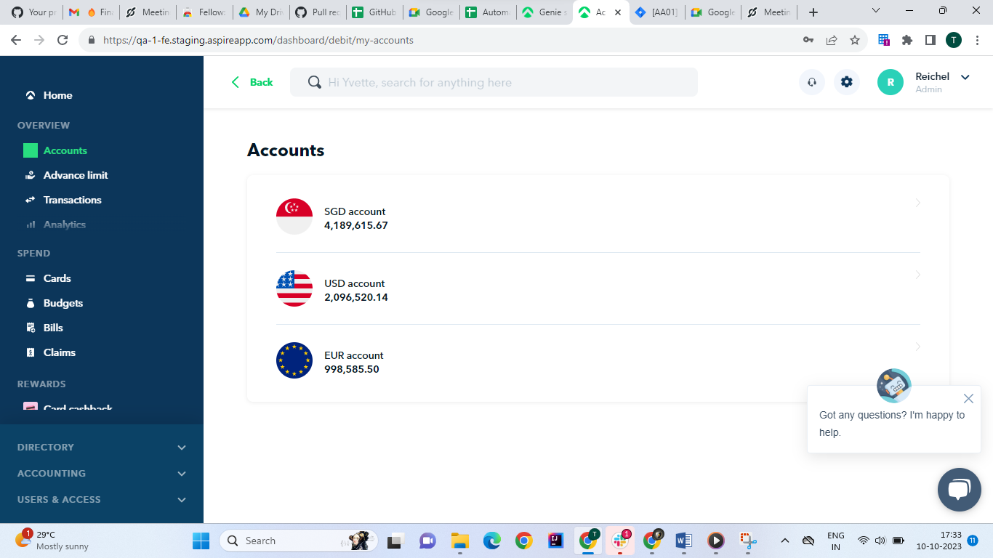

Account Details Page
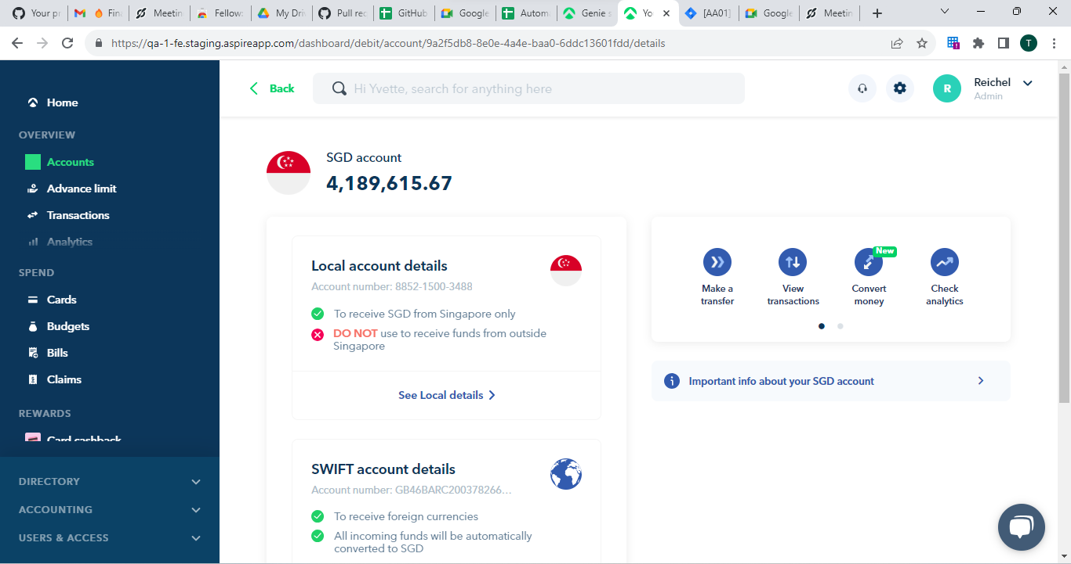

Recipient Page
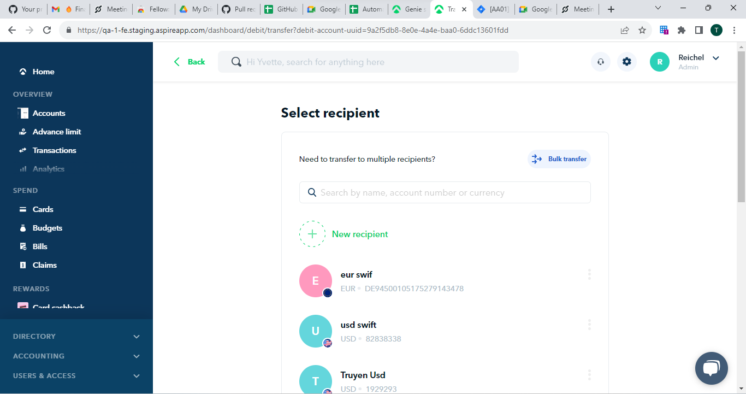

Transfer Page
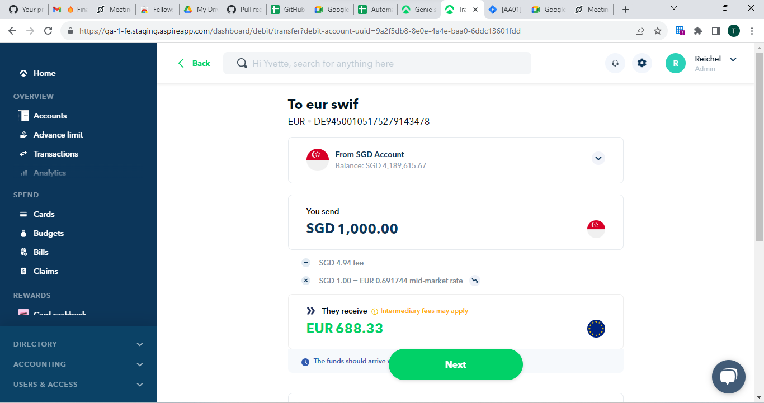

Transfer Review Page
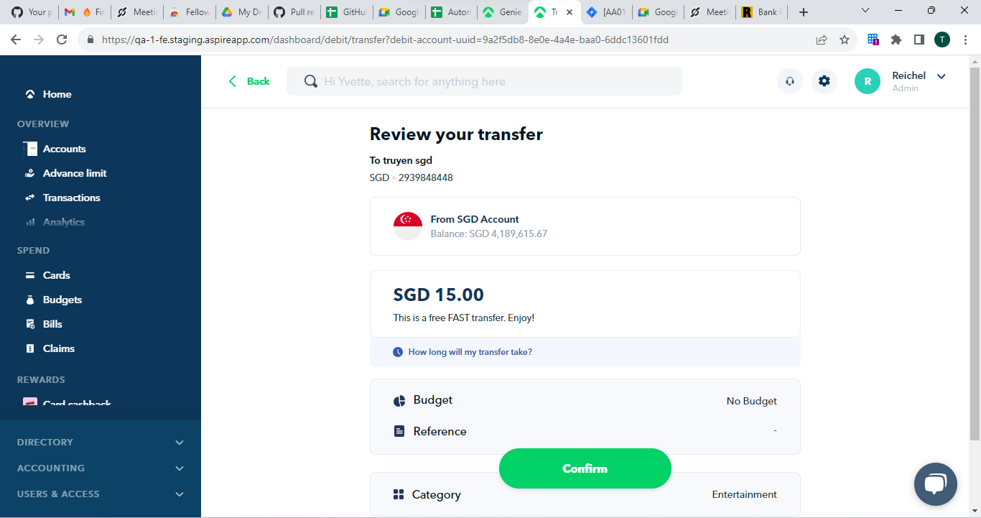

Transfer Initiated Page
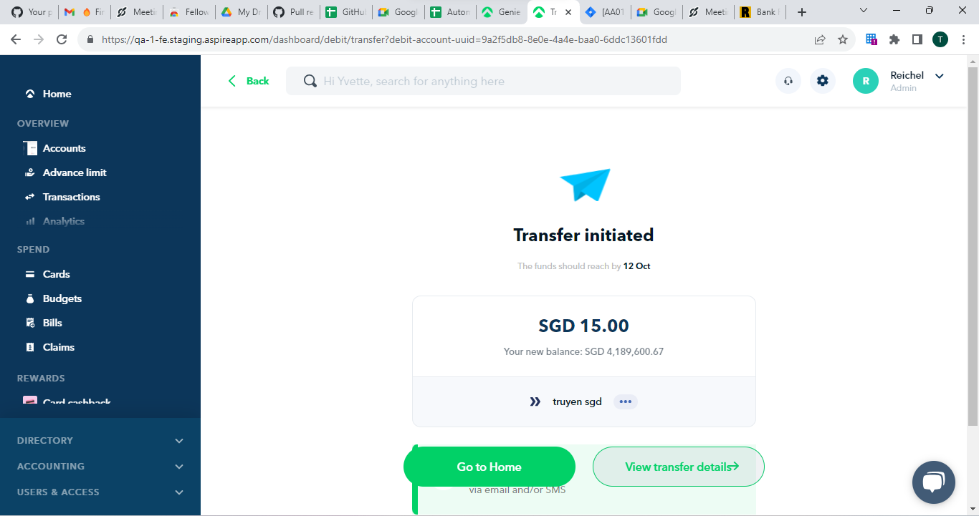

Transfer Details
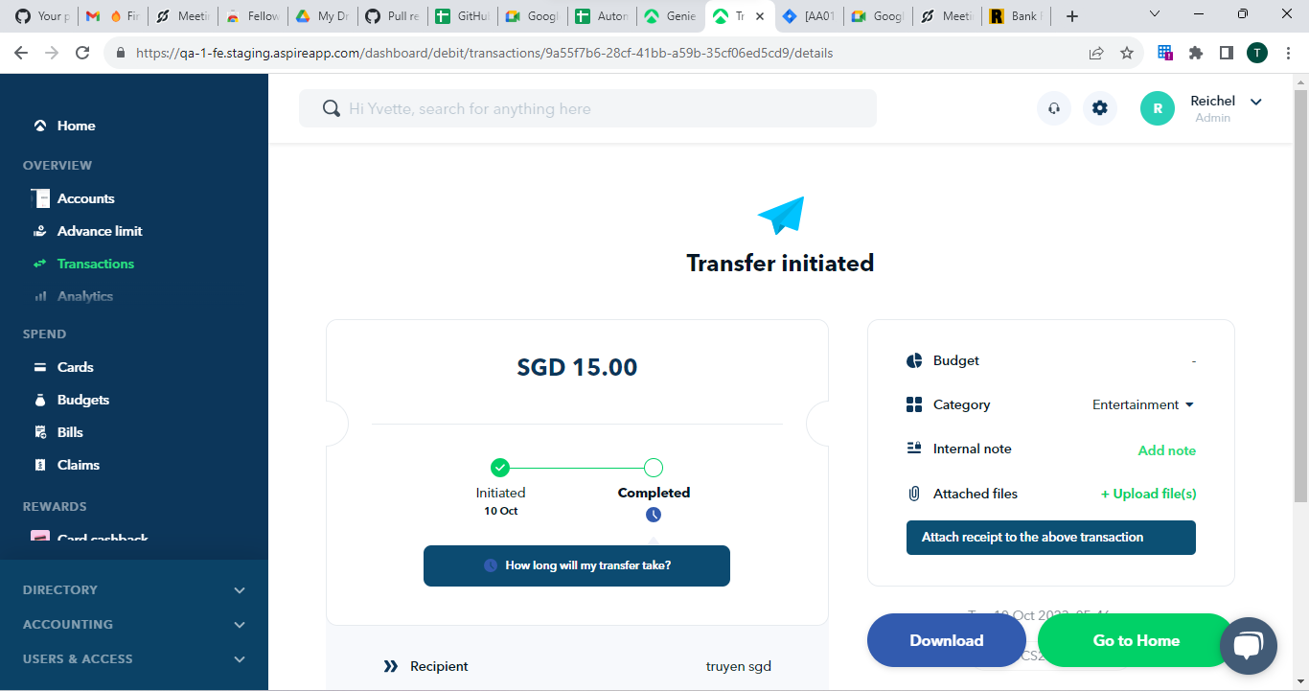

Transactions Page

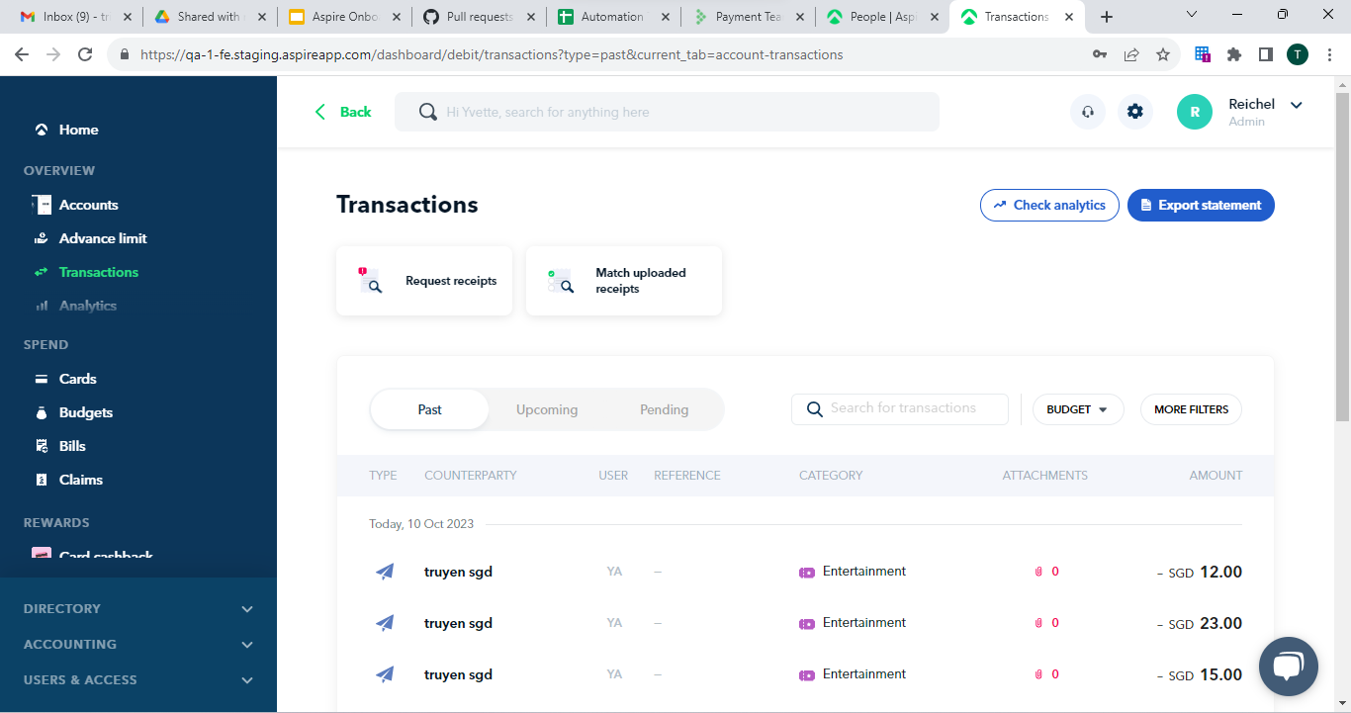

Create Business
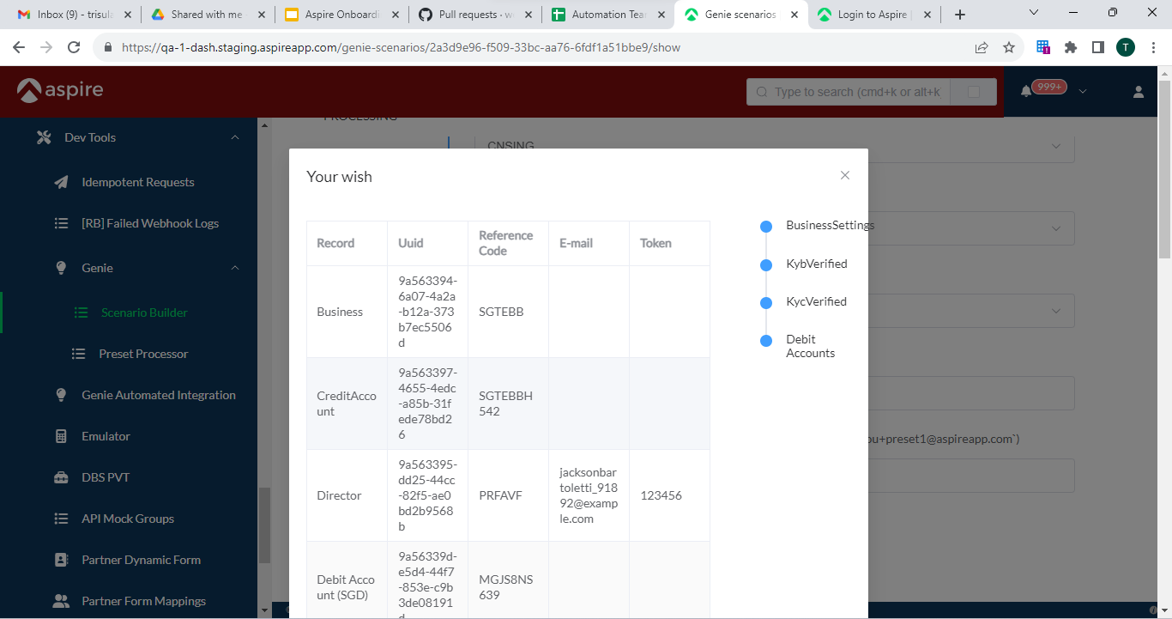

Finance Submit only
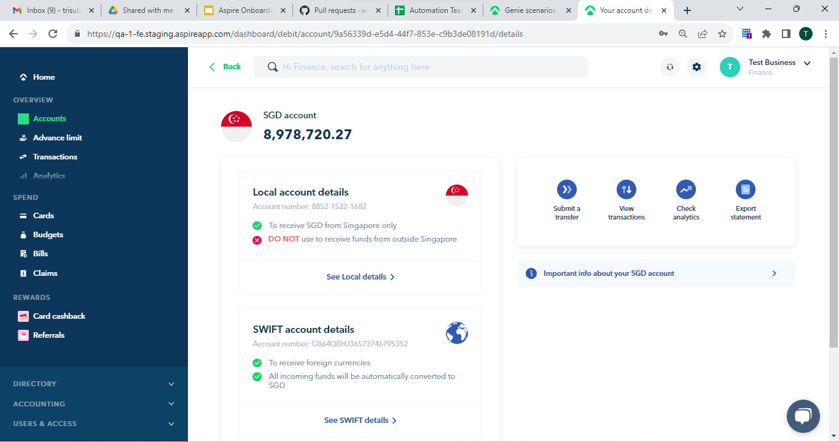

Submit Transfer
